Pathfinder Business Analysis Pvt Ltd

Commercial Sales Research

Research & Identify the County Cad Site

- Select the Account Number with given county and State in Excel
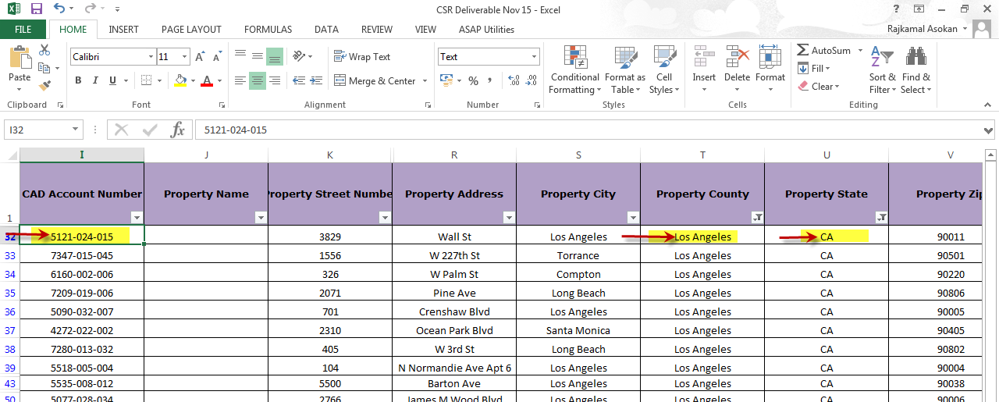

- Search the County with using of State in “Netronline” for collection of data as we needed,
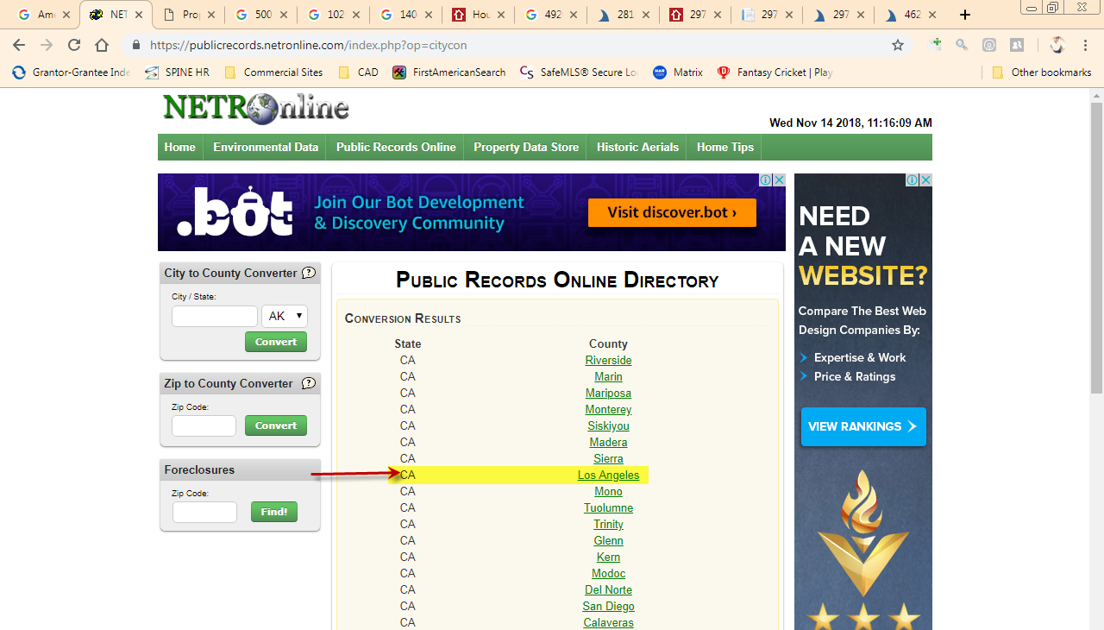
CSR Production Template
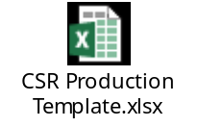

- Select the Assessor/Appraiser/GIS only on “Go to Data Online” for fetching the information about the property
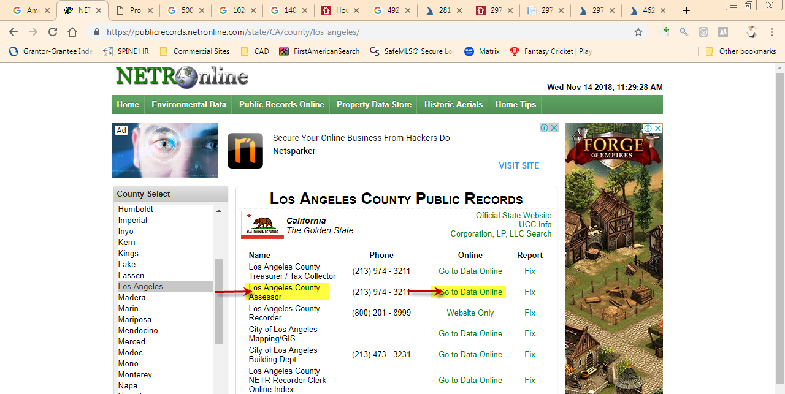

Use the general search for Property information with its address (Property Shark, Realtytrac, Loopnet..) if we couldn’t able to access the CAD Site means,
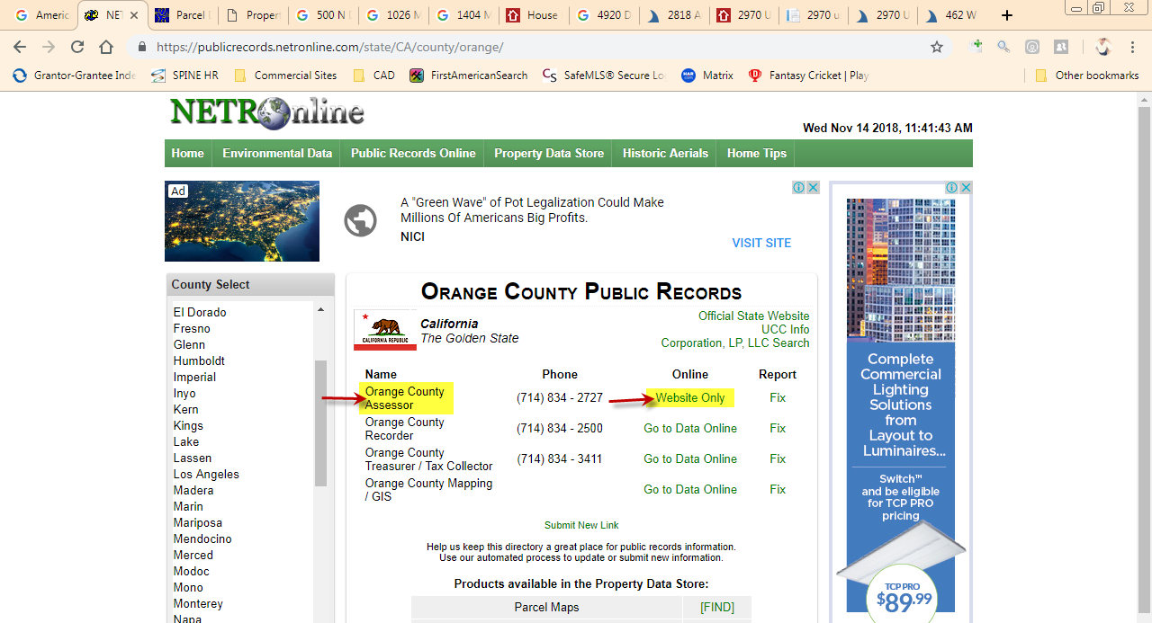

- Check whether the Property is Commercial/Residential (If property is Residential then Skip the file)
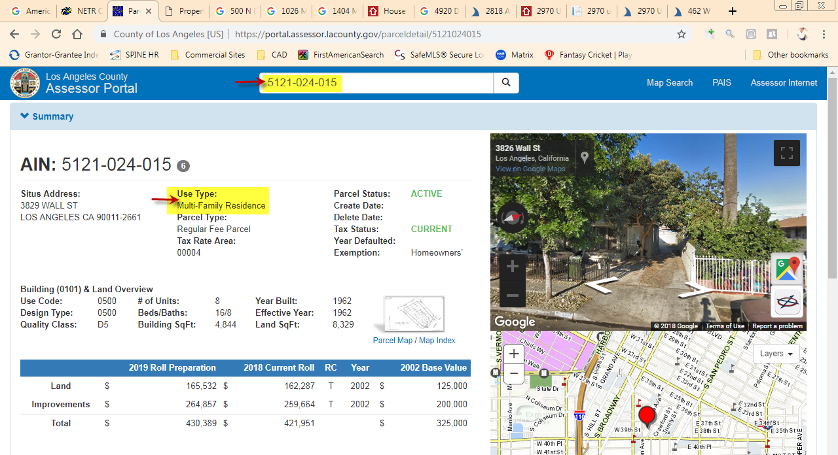

By using Property address in general search, confirm the Property Type with its account number and Address for reference (If property is Residential then Skip the file),
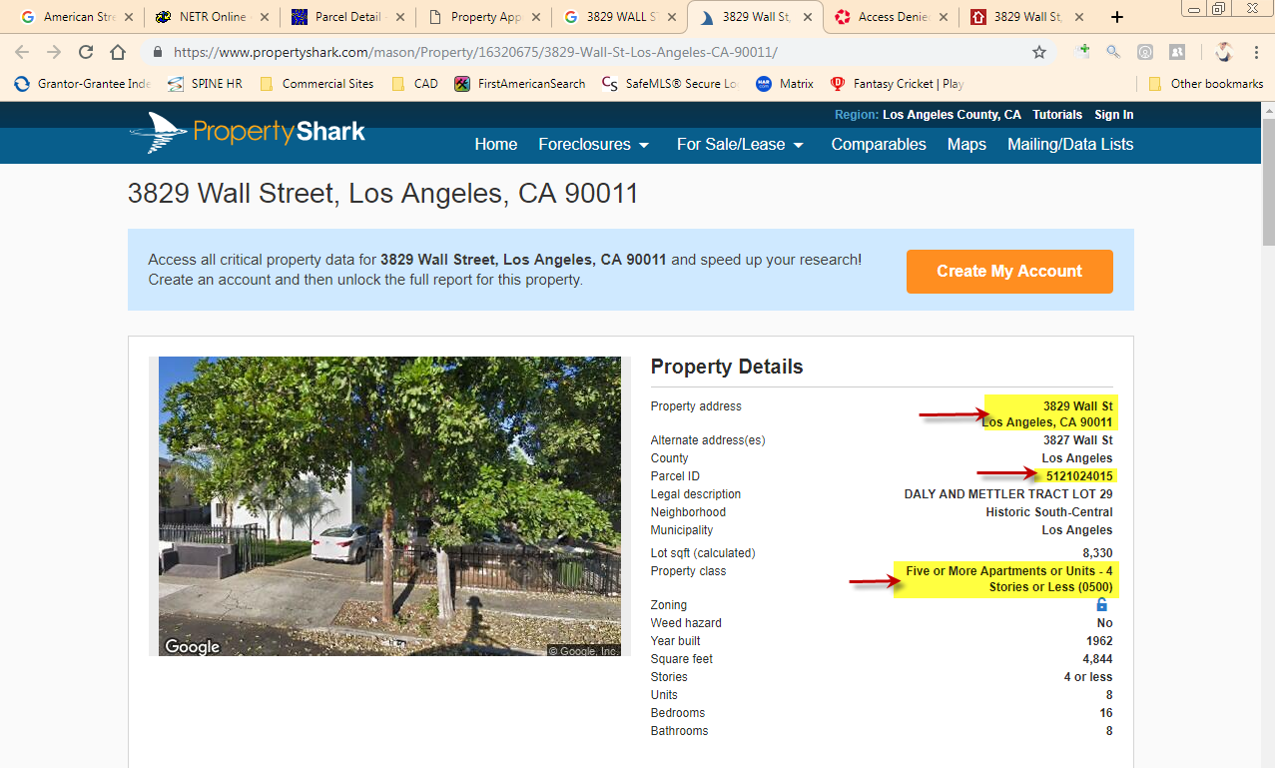

Property Type & LUC

- Find the Property Sub type with stories & LUC using CAD site/General Search
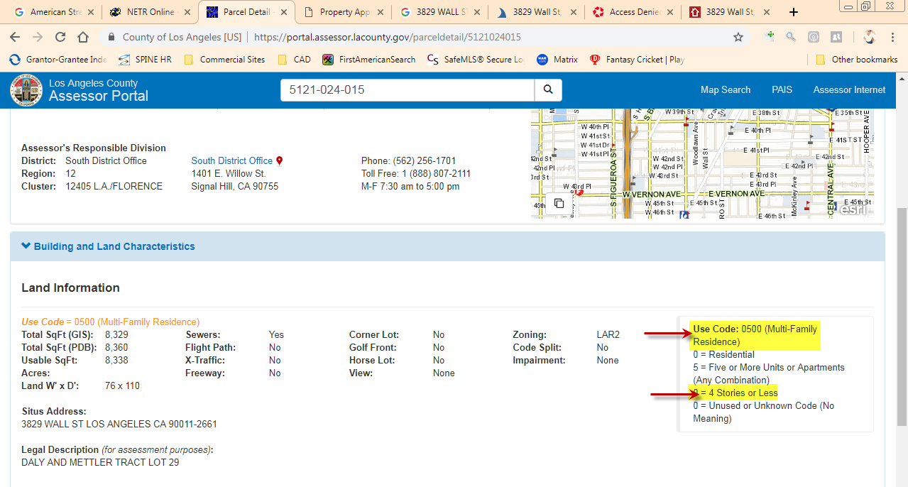

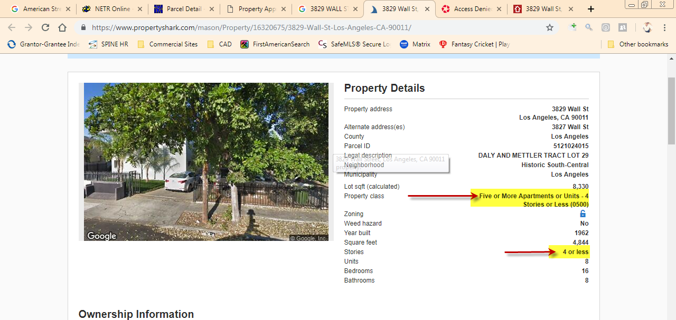

- Use the OCA LUC master to find the Property Land Use Code on based of stories available in CAD Site
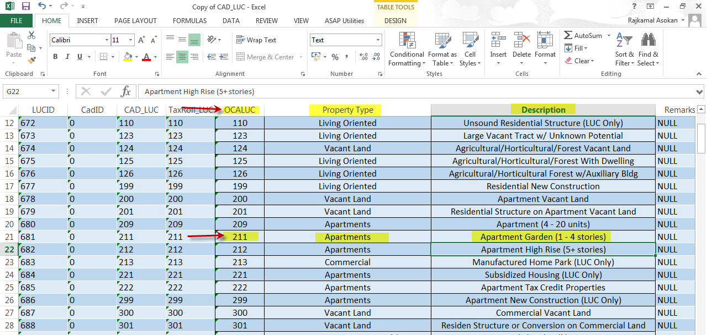

Reconfirm the Property Type by using Google Maps
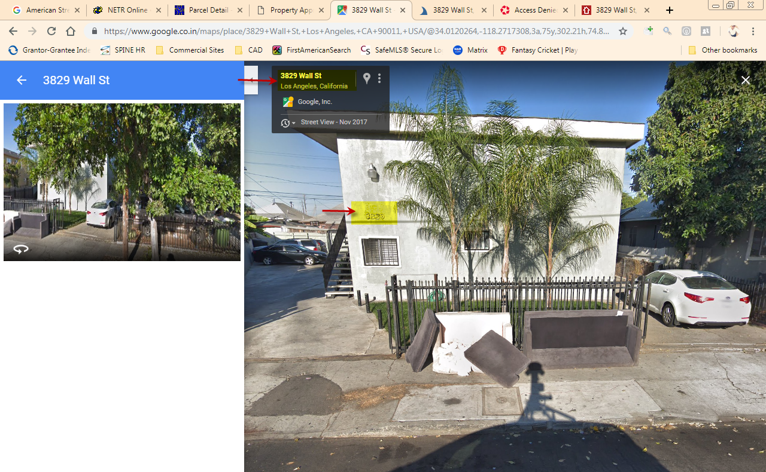

Land Size, GBA & Swimming Pool

- Find the Land Size and GBA value in CAD Site respectively,
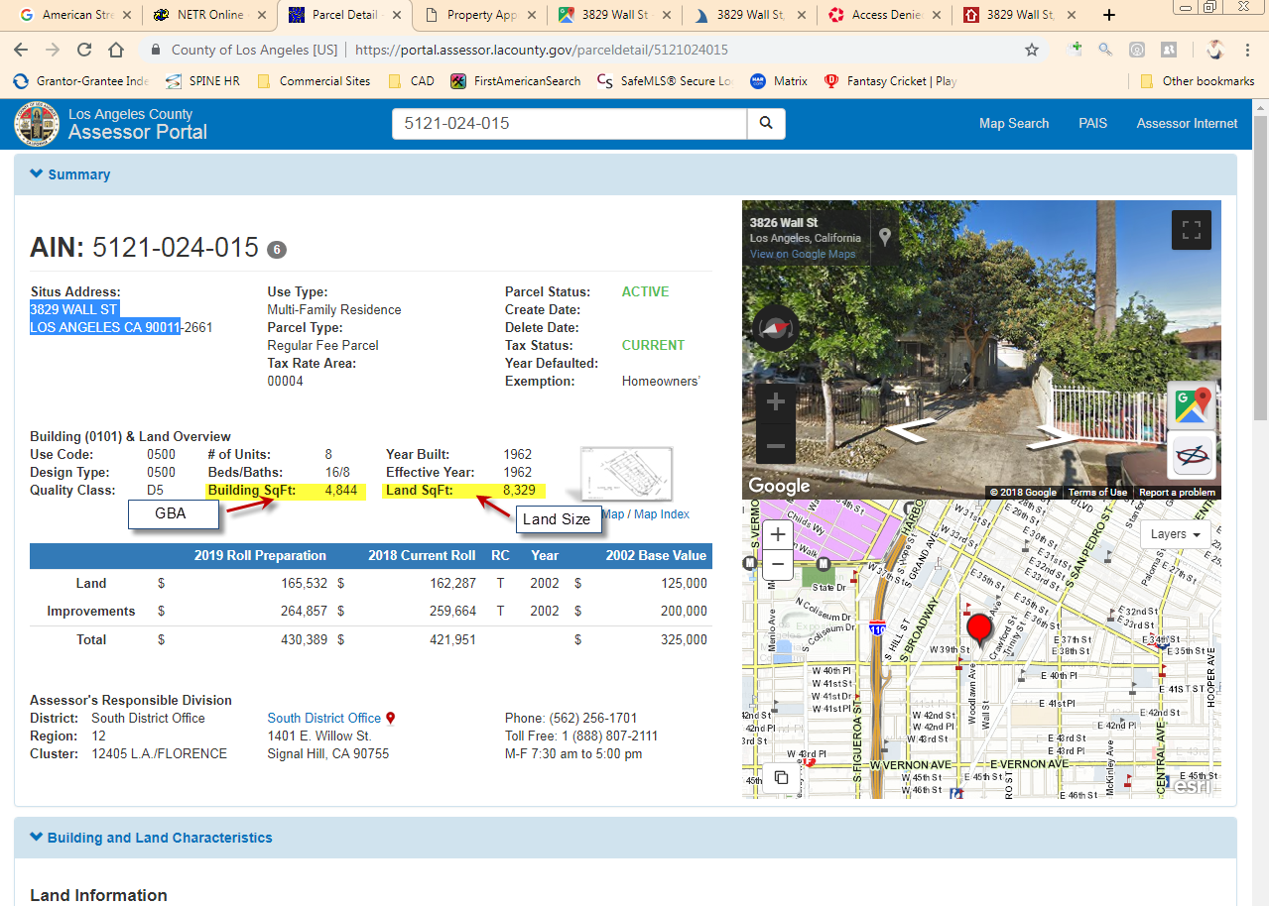

- By using General Search for Land Size and GBA,
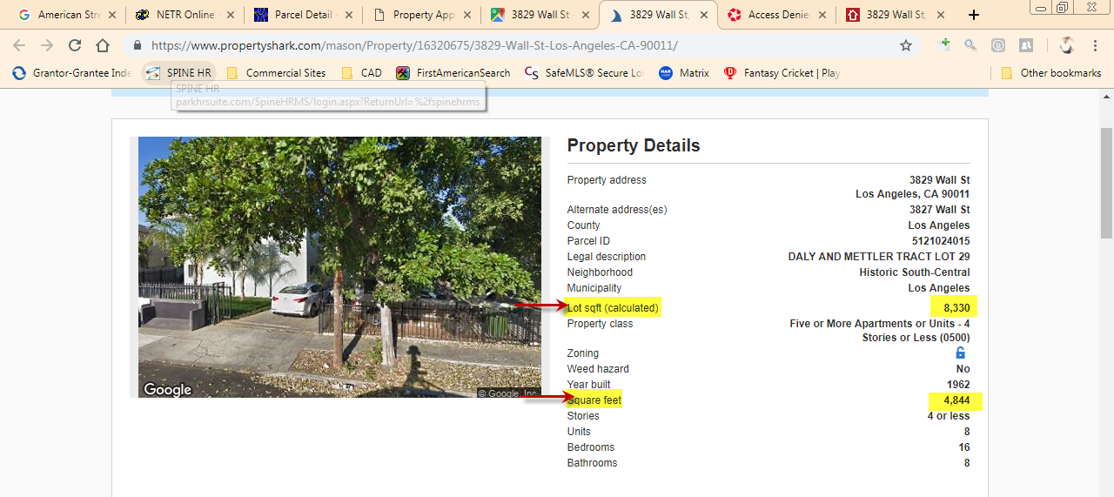

- If Land Size / GBA is not available in general site then measure and update the values using Google Maps,
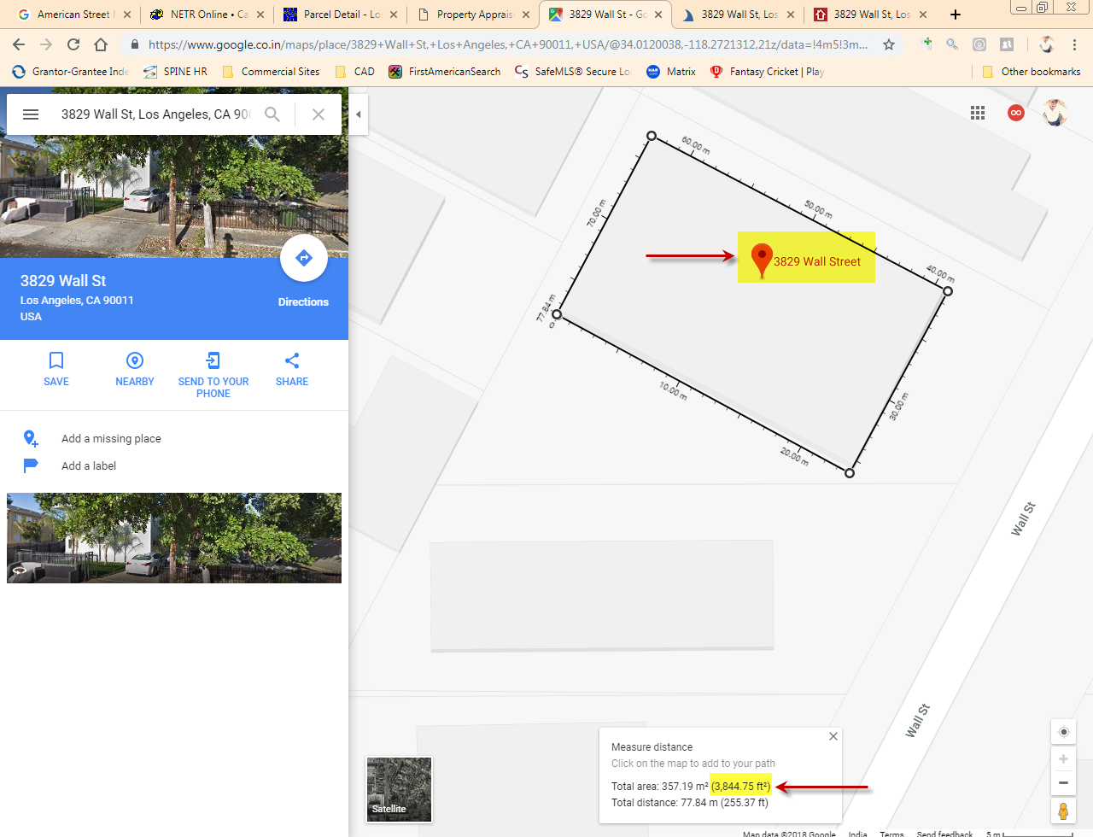

- Meanwhile search the property address in google and locate in it,
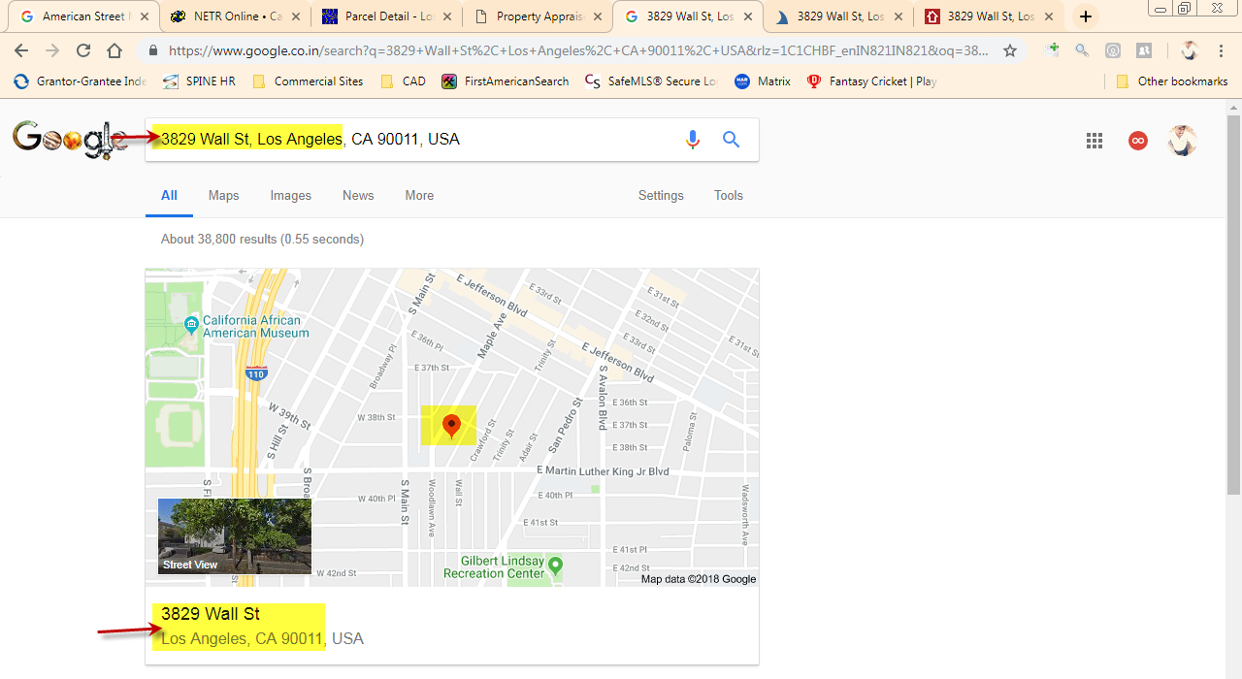

Using the Satellite view of search property, check whether swimming pool is available or not,
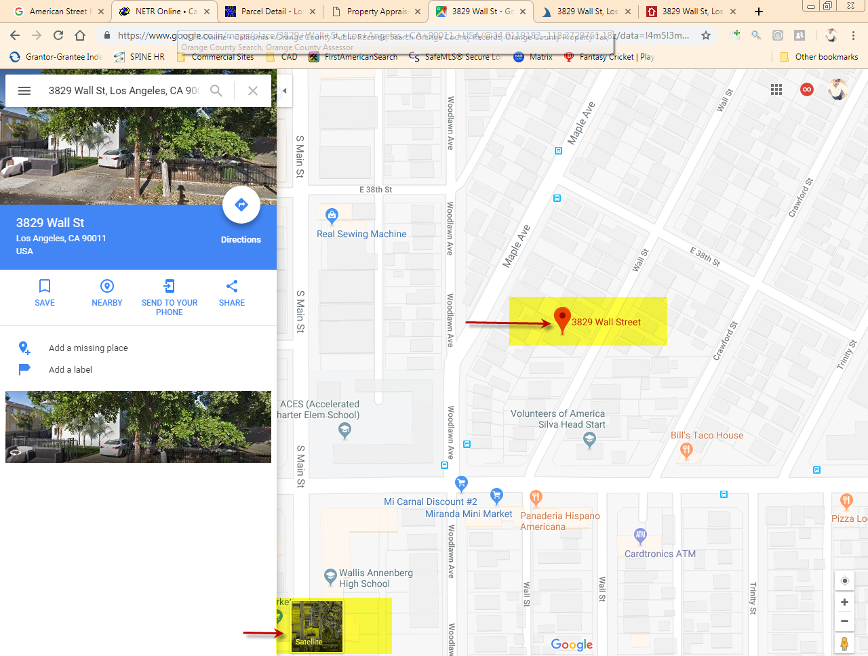

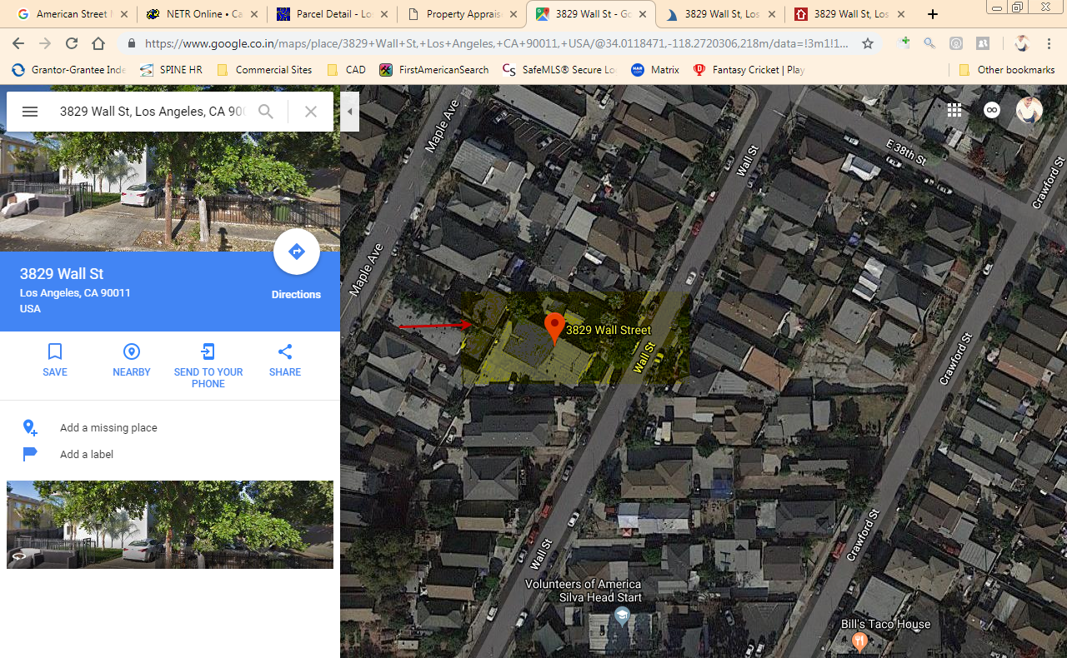

Use Deed/DOT for Contact person

- Use the recorder option in “Netronline” to find Deed/DOT of respective names
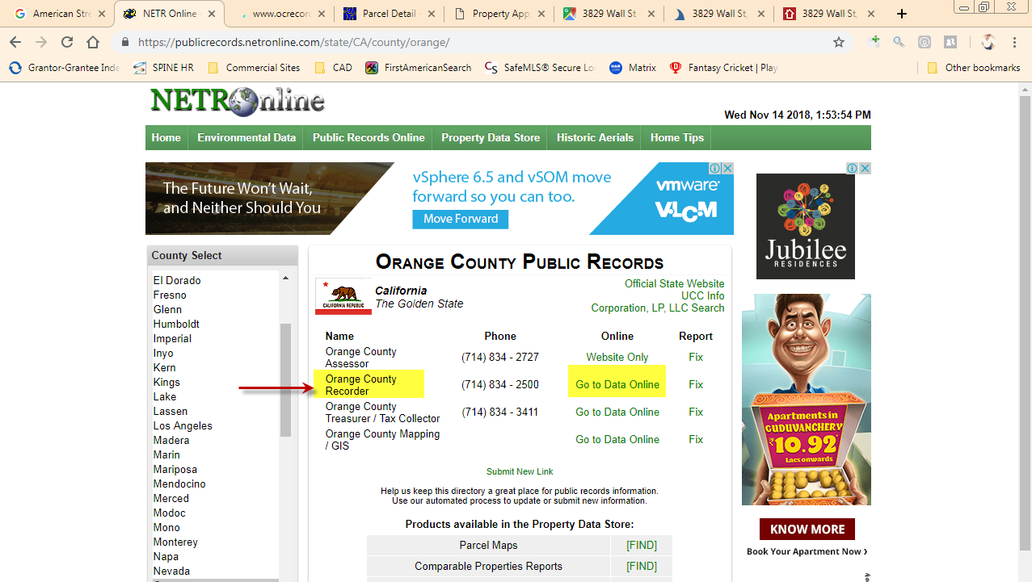

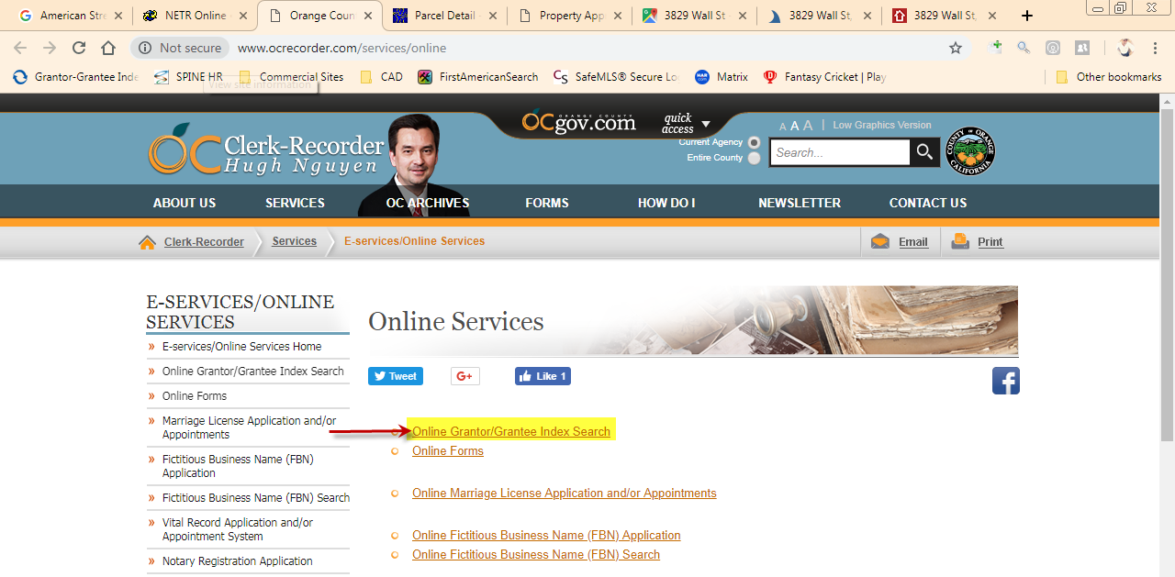

- Find the Buyer Contact (Signed Person) using any of following option in recorder site

- Name
- Document Number
- Recording Date
- Document Type
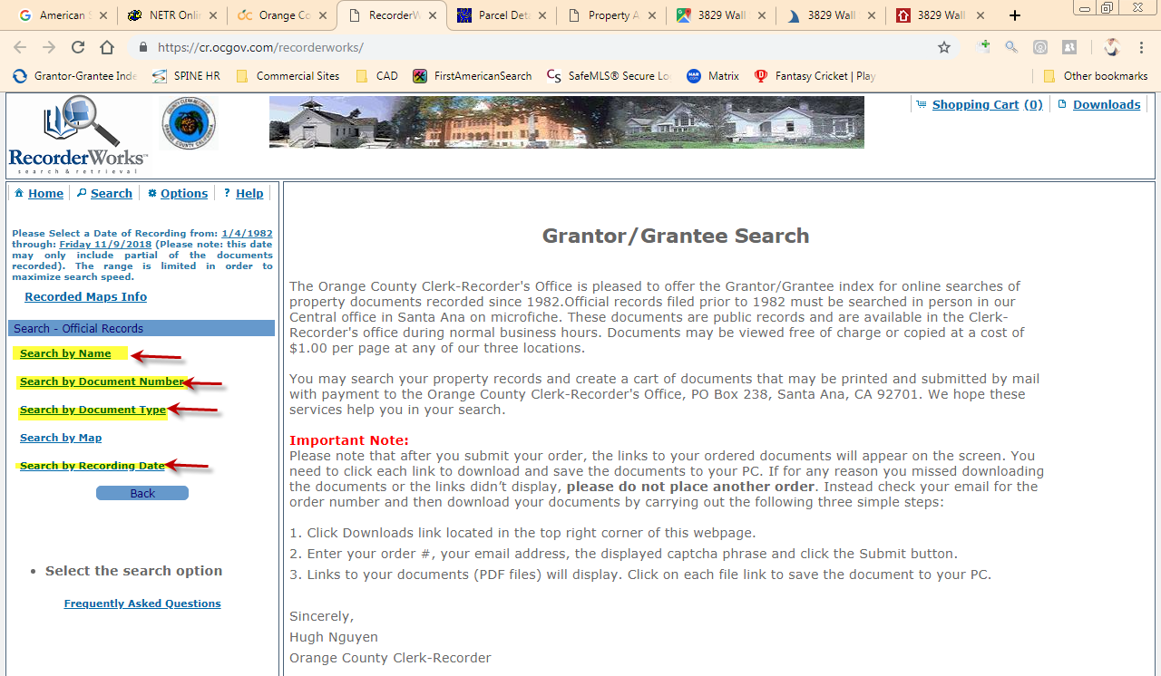
- Select the Deed/DOT image which will be available in the recorder
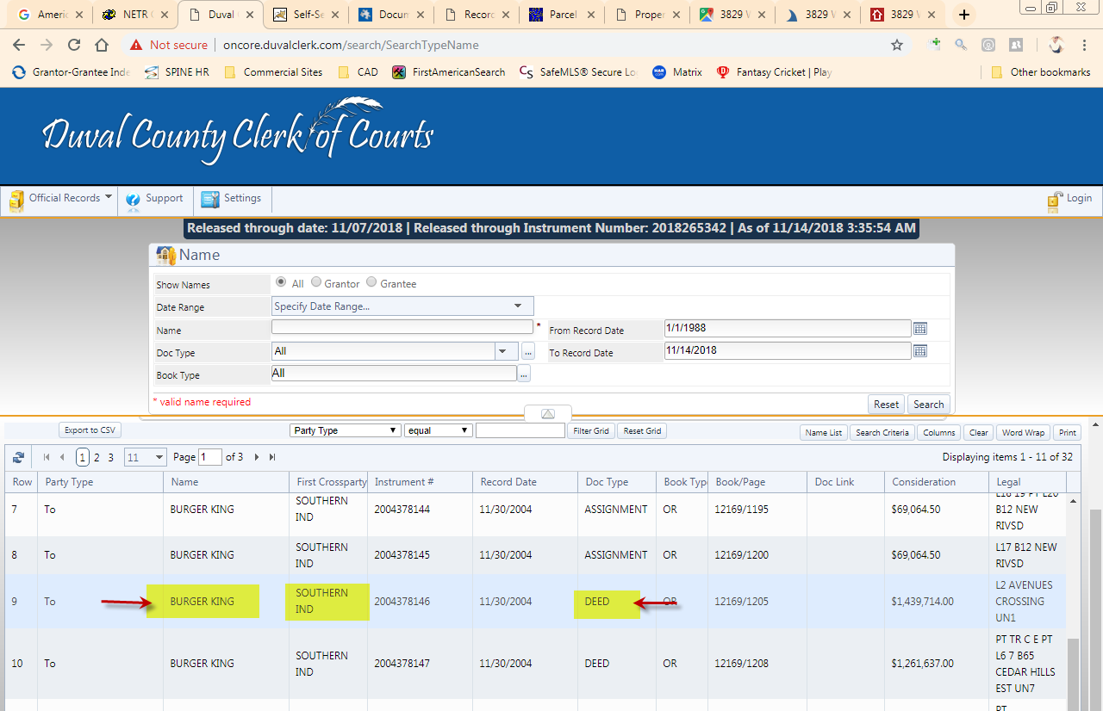

Search for Buyer Signed Contact person in Deed/DOT with specified designation
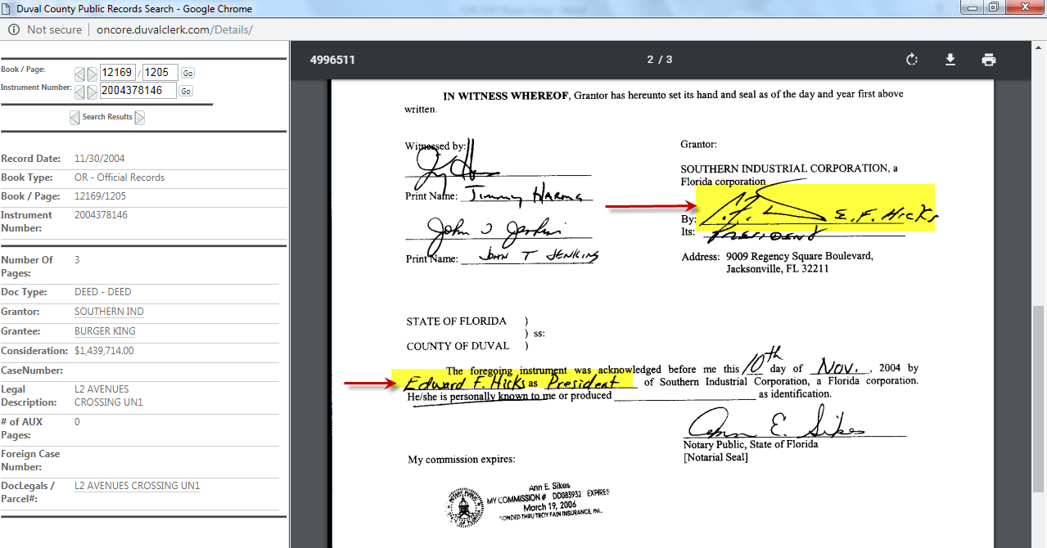

- If County recorder site is not available, use SOS (E-Secretary of State) for Contact person with Entity Search Option
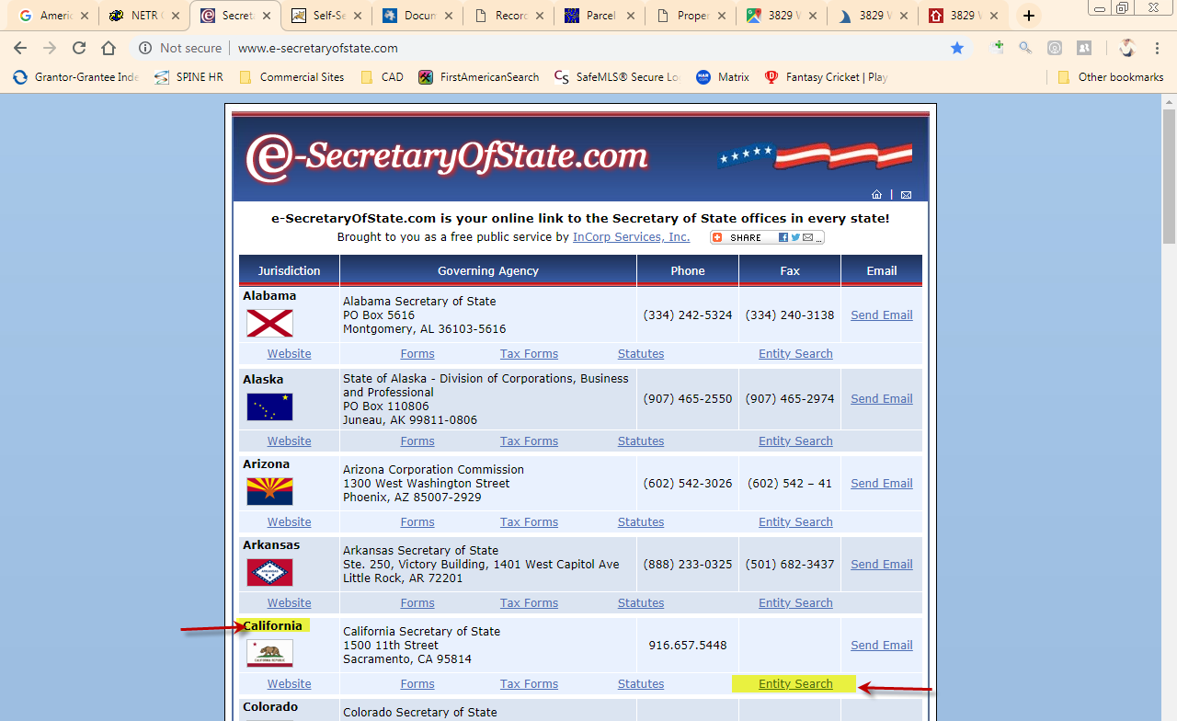

Select the Entity Name which we are looking in SOS (Active Status)
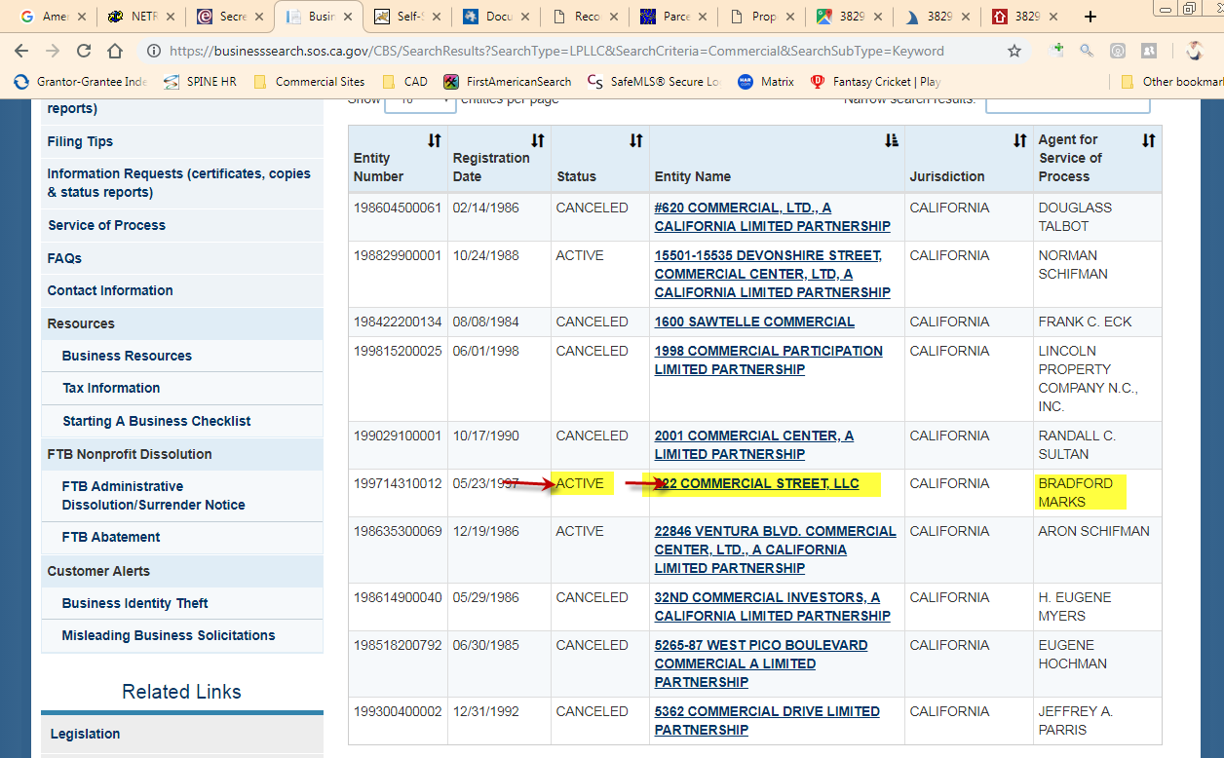
Pick the Contact Person from the SOS using the general and confirm it by selecting the PDF available
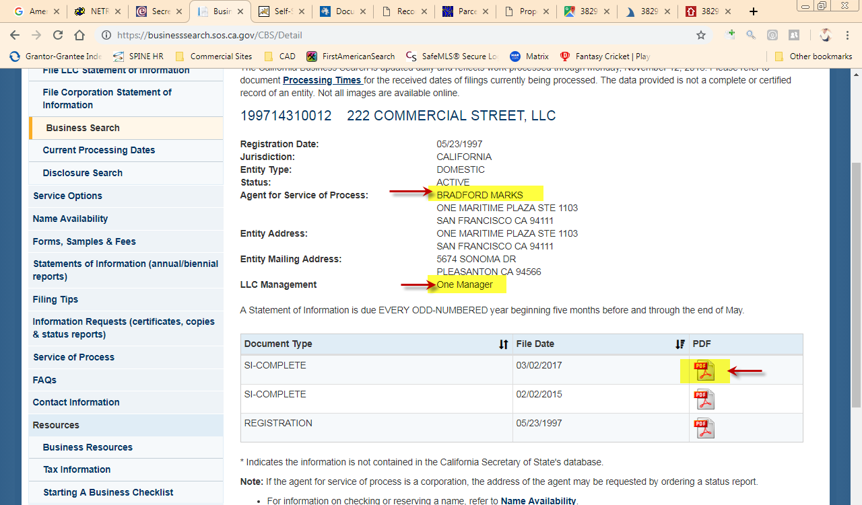

Contact Search of Buyer/Seller

- Find the contact details using Buyer Company with Contact person we found,
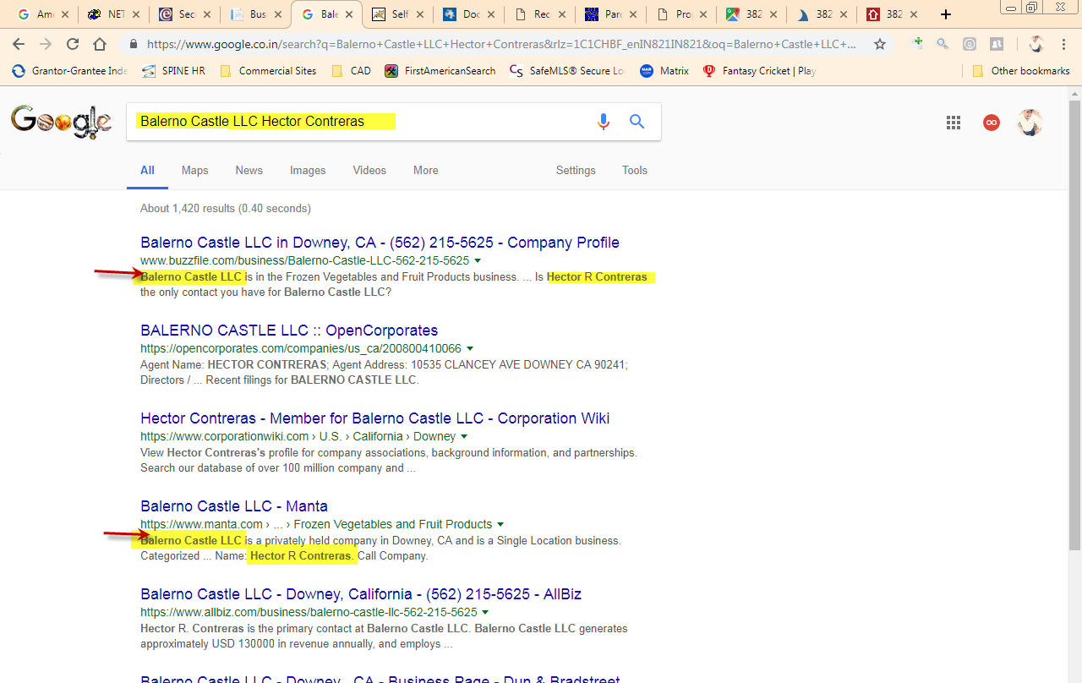
- Another method try to find the information using Contact person with Buyer address,
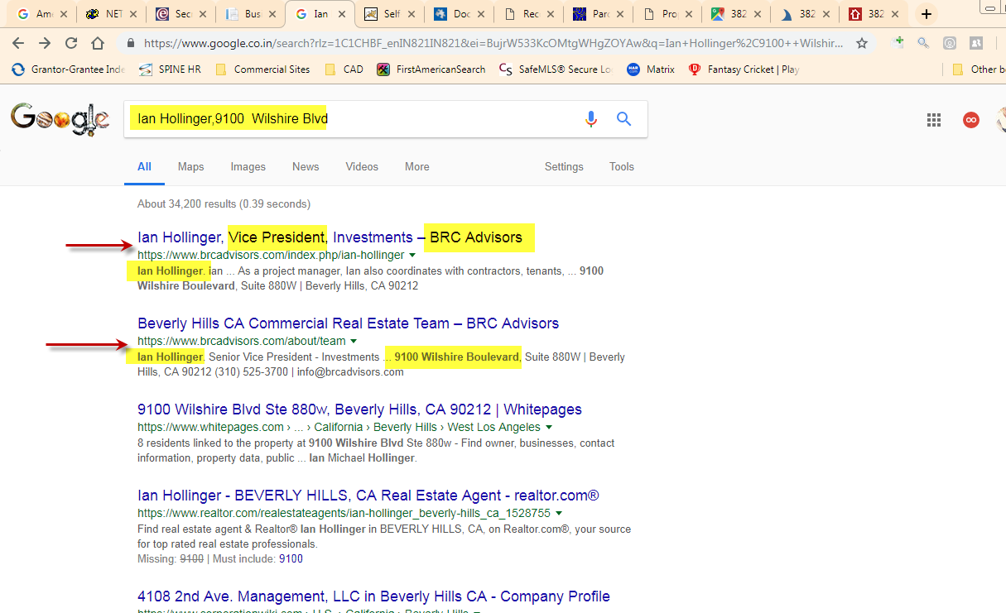

- Update the Contact person number and Company number with fax number in the respective fields using website and general search
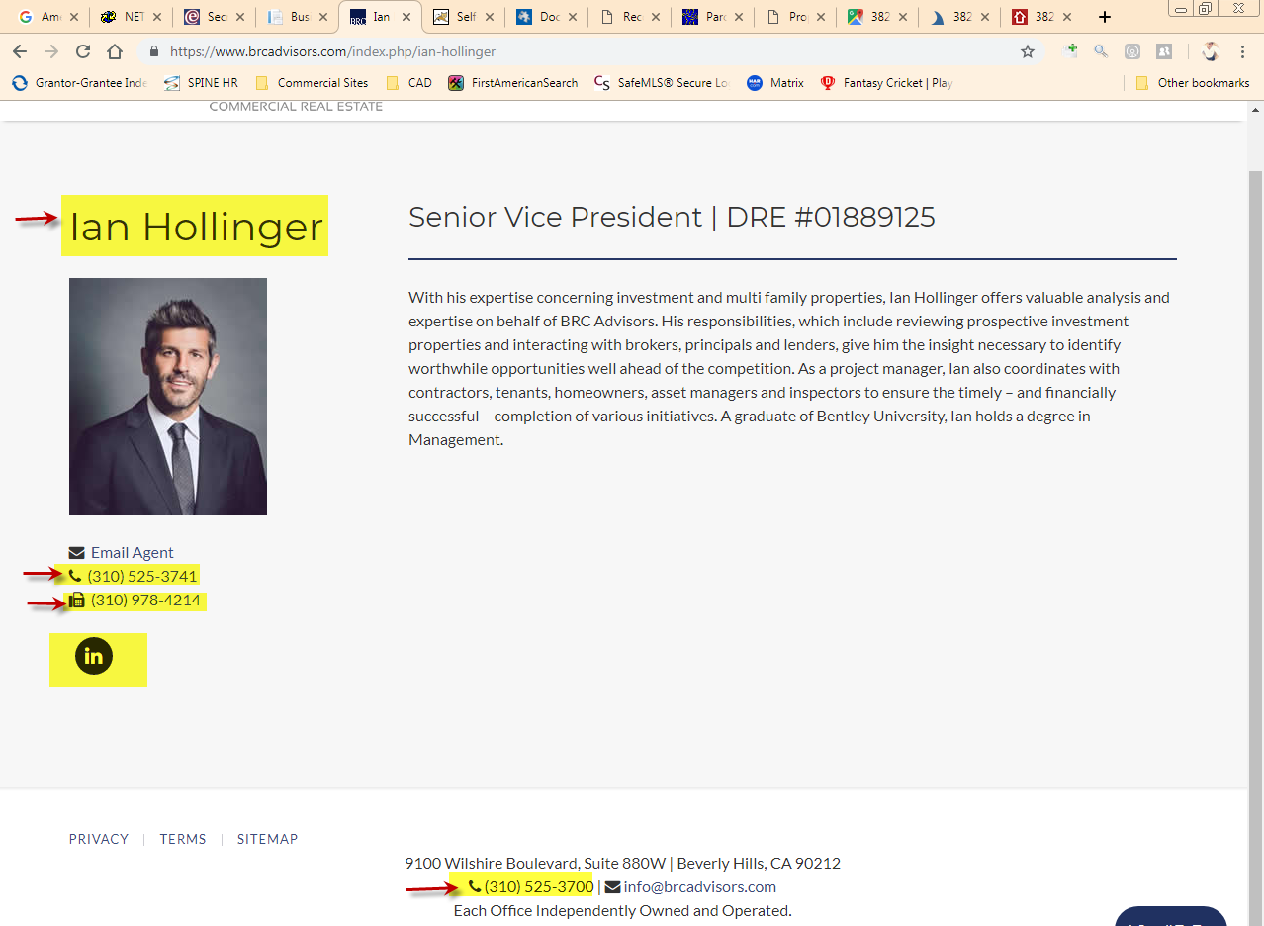
- Get the Email ID, LinkedIn, Twitter, Facebook details of Buyer contact in Website or using general search
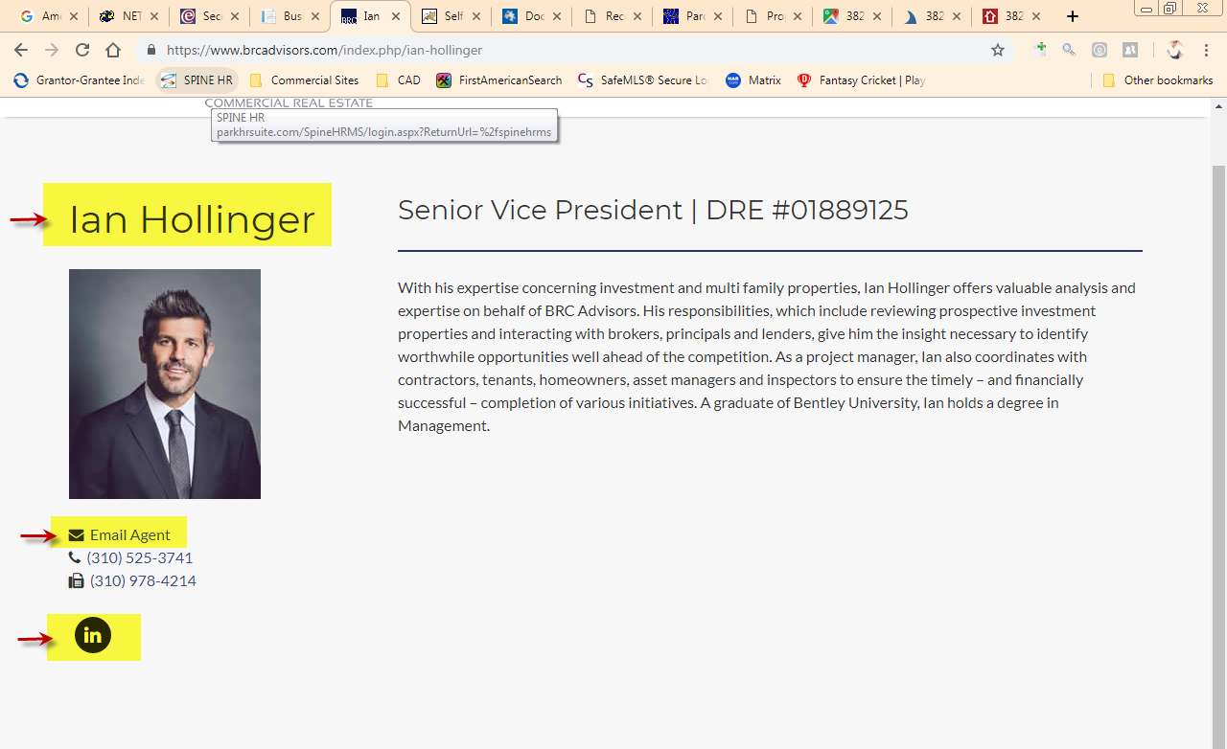

Validate the Email ID by using Test Mail in prevention of bounce back
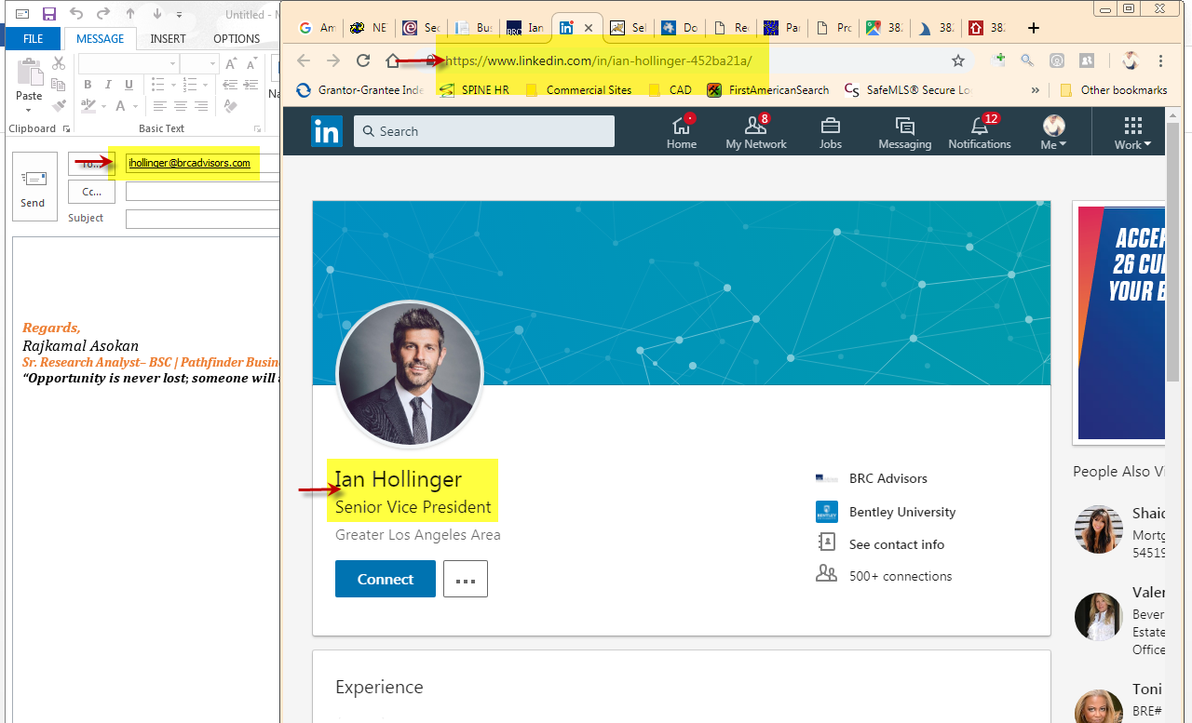
Try the different methods to find the social media information for the Contact person
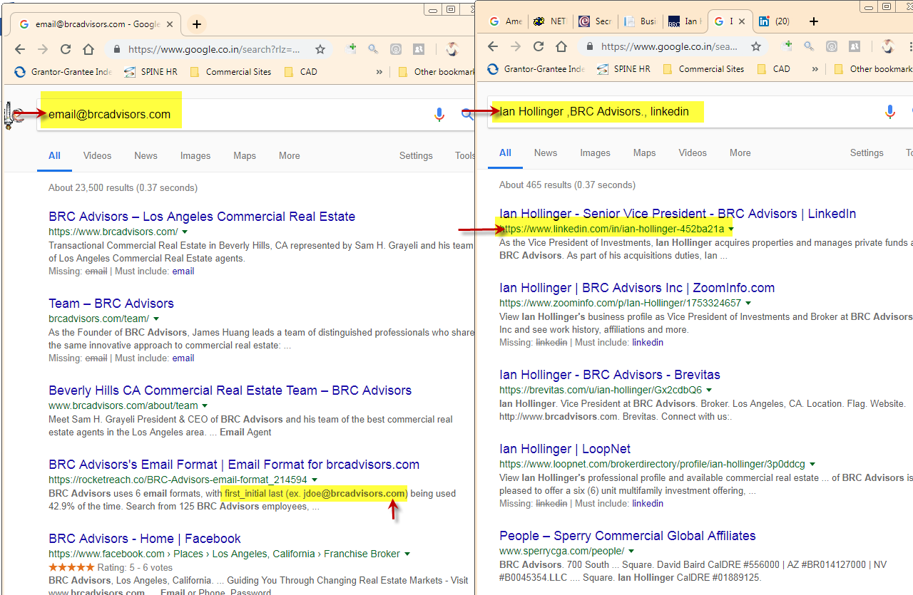

- Use the Valid Email ID’s which we found for Facebook and Twitter searches,
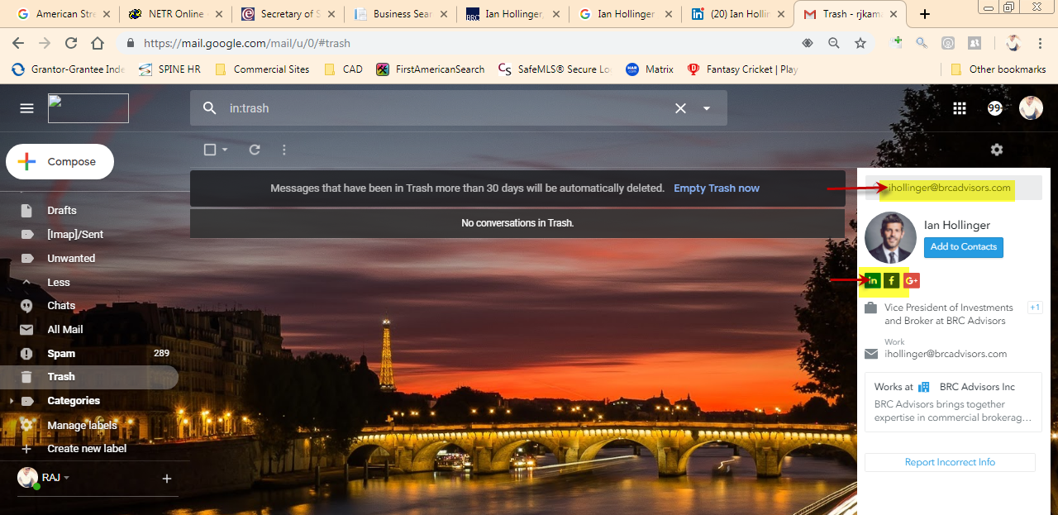
In other case use the Company name along with contact person to find out the Facebook and Twitter links
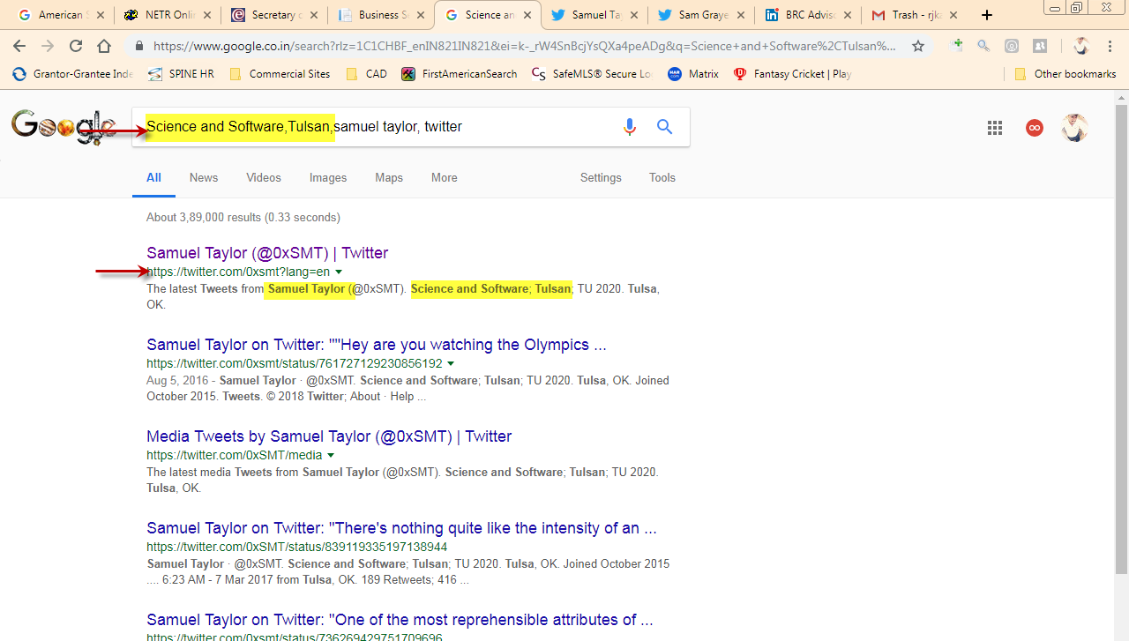

“Use the Property address or Address from Deed/DOT/CAD for Seller Contact Research and follow the same procedure as like Buyer search”

Advisor Mapping and Google View

- Map the Buyer State with Advisor Mapping sheet available

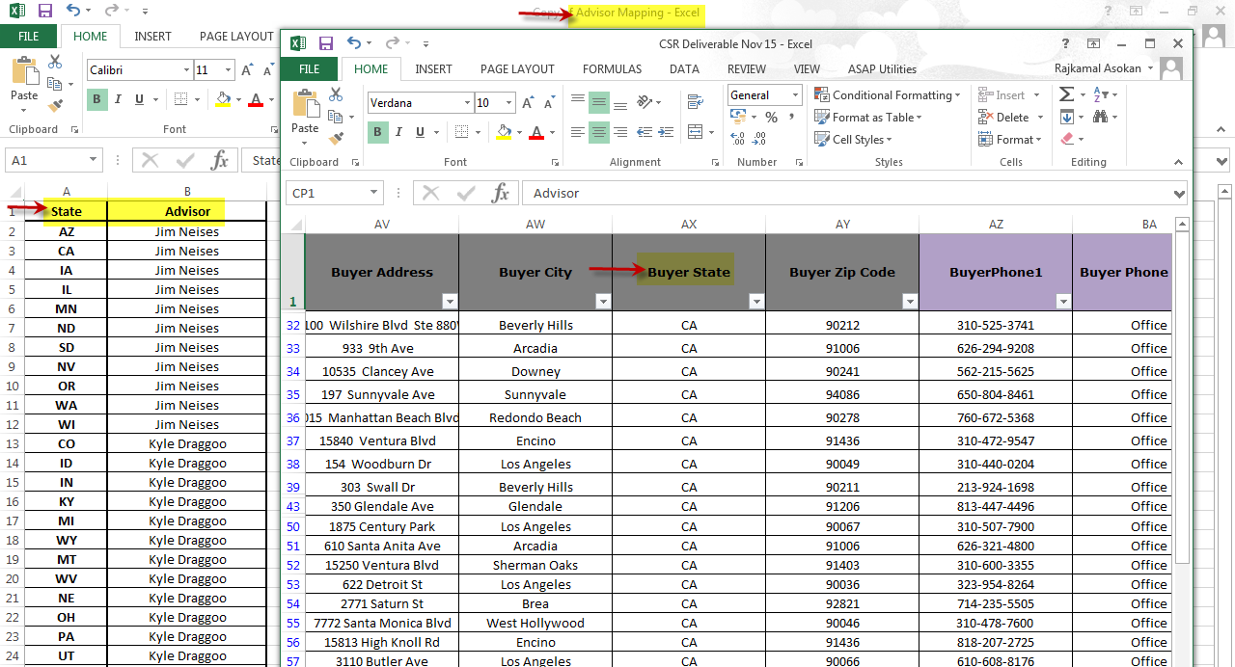

- Search the Property address in google and locate in the property in street view ,
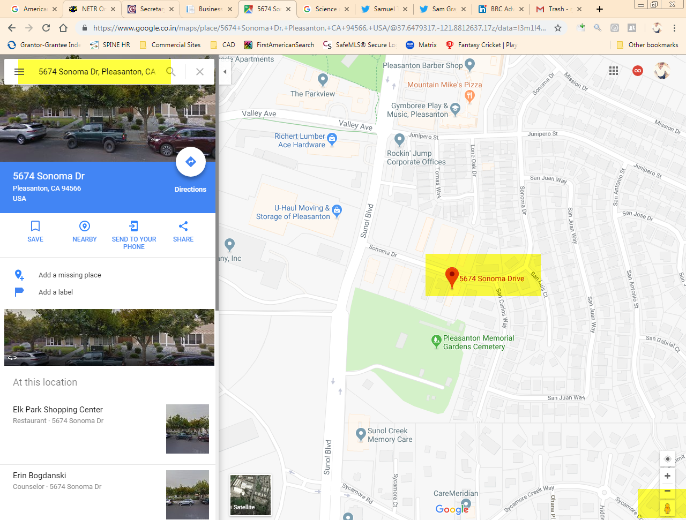
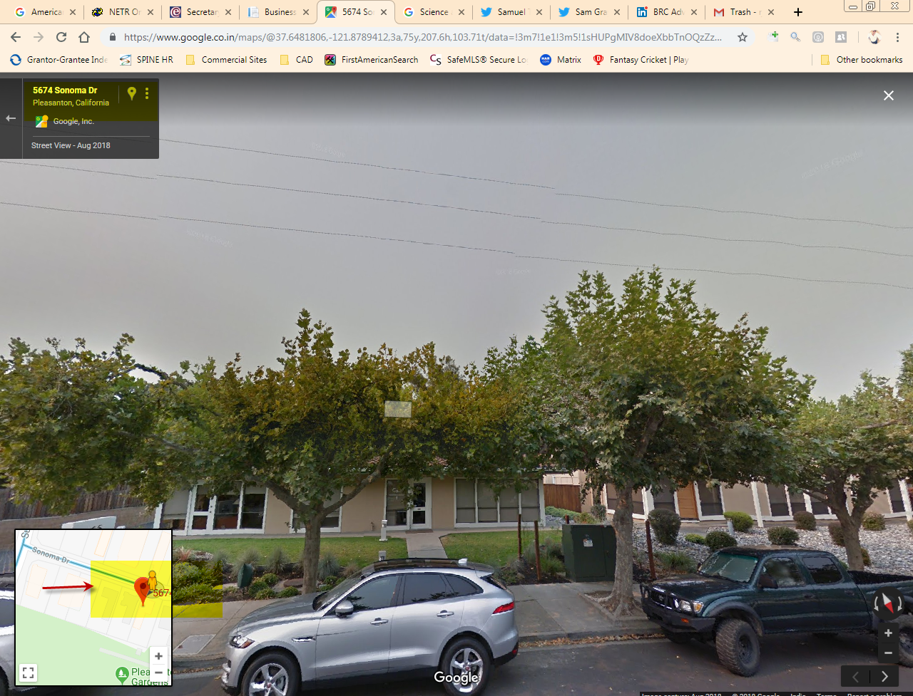

CSR Enriched Data Template
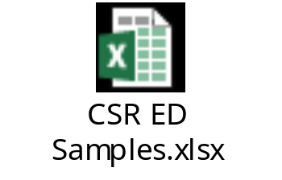

CSR Deliverable Template
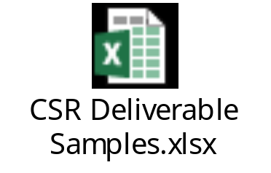

CSR Sales Uploader Template
